Mustafa Abdullayev

An Inventory Management Decision Model

AY6050 – Intro to Enterprise Analytics

Term: Winter 2020

Instructor: Roy Wada

03/17/2020

# Introduction

This is Microsoft Word Report accompanying my R Script and Excel Worksheet. In this analysis, my main aim is to perform what-if scenarios and optimization techniques for an Inventory Management. I was given parameters, data and business scenario and I devised a model for decisions making for optimal inventory management. Then, I used Excel and R for optimization techniques to optimize the efficiency of my model . There are two parts to my analysis. In the first part, yearly demand for specific product was given as a constant number, uniformly distributed over the months. I utilized Excel Solver in order devise an optimal model for ordering decision. Also, I used one-way and two-way data tables to perform sensitivity analysis for Total Cost.

Main difference between parts was about distribution of demand. In the second part, I assumed demand to has a triangular distribution with specific parameters. Again, for different demand values, I utilized R in order to optimize Total Cost. Moreover, I used R graphs and charts in order to observe the distribution of different parameters associated with calculation Total Cost.

Since I also provided R script and Excel worksheet with all the codes and comments, I removed some of the codes and comments from my report (such as package loading). Also, I did not incorporate all of my R code to report since it was too lengthy. However, all necessary outputs (Tables and graphs) are added. It is due to keep my report brief, succinct and to the point.

# Part 1 – Excel Analysis

In first part of my analysis, I was given different parameters and variables and was asked to find an optimal number of pieces to order in each order and optimal number of yearly orders. Here, demand is my uncontrollable variable since I have no control over it. Demand value was 17700 for a year, and it was uniformly distributed for 12 months. I have 4 different parameters namely, Holding Cost, Ordering Cost, Number of orders and number of Quantity in each order. Yearly holding cost for each unit for a company was 16.9% of Unit Cost (82 USD). Converting it to Dollar value, company must pay 13.86 USD as a yearly holding cost for each unit. On the other hand, every order costs 212 USD regardless of amount of quantity in it. Ordering policy is to wait until inventory fall to predetermined limit (average inventory amount) and then order twice as much as units. Finally, my decision parameter is Total Cost. Total Cost is the ultimate factor that I am trying to minimize. Considering these parameters , my main aim is to find optimal number of yearly orders and amount of quantity in each order in order to minimize Total Cost.

To begin with, I separated Total Yearly Cost in0to two different parts : Total Yearly Holding Cost and Total Yearly Ordering Cost. In order to calculate total Holding cost, I multiplied average number of pieces in the inventory with holding cost for each unit. Since in the problem description , it says that company order twice as many units as predetermined lower limit, I assumed average inventory throughout the year is the half of optimum order quantity.

$Average Inventory = Order Quantity ÷2$*(1)*

$Total Holding Cost = Average Inventory × Unit Cost × Holding Cost$*(2)*

For the second part, Total Ordering cost is the multiplication of Number of Orders with Ordering Cost which is 212 USD. In order to find number of orders, I divided total demand by ordering size, since we do not want to order more or less than our yearly demand.

$Total Ordering Cost=Number of Orders ×Ordering Cost$*(3)*

Combining second and third equation would give me the Total Yearly Cost. In order to keep it simple I will write Total Yearly Cost as :

$Total yearly Cost=Total Holding Cost+Total Ordering Cost$ (4)

After defining my variables and mathematical formulas to calculate Total Yearly Cost, I used One-Way table in Excel in order to observe effect of different Order sizes in Total Yearly Cost. From below table (Table 1.1), we can see that optimal number of order size lies between 730 and 740 since our total yearly cost tends to be minimum here.

*Table 1.1 – One-Way table for Order size vs Total Cost*

|  |  |  |  |  |  |  |  |  |  |  |  |  |  |  |  |  |  |  |  |  |  |  |  |  |  |  |  |  |  |  |  |  |  |  |  |  |  |  |  |  |  |  |  |  |  |  |  |  |
| --- | --- | --- | --- | --- | --- | --- | --- | --- | --- | --- | --- | --- | --- | --- | --- | --- | --- | --- | --- | --- | --- | --- | --- | --- | --- | --- | --- | --- | --- | --- | --- | --- | --- | --- | --- | --- | --- | --- | --- | --- | --- | --- | --- | --- | --- | --- | --- | --- |
| |  |  | | --- | --- | |  |  | | **Number of Quantity** | **Total Cost** | |  | 10198,1 | | 600 | 10411,4 | | 610 | 10378,2 | | 620 | 10348,2 | | 630 | 10321,5 | | 640 | 10297,7 | | 650 | 10276,8 | | 660 | 10258,6 | | 670 | 10243,0 | | 680 | 10230,0 | | 690 | 10219,3 | | 700 | 10210,9 | | 710 | 10204,7 | | 720 | 10200,5 | | 730 | 10198,4 | | 740 | 10198,3 | | 750 | 10200,0 | | 760 | 10203,4 | | 770 | 10208,6 | | 780 | 10215,4 | | 790 | 10223,8 | | 800 | 10233,7 | |

To continue, I plotted Total Yearly Cost vs Ordering Size (Figure 1.1). Again, it is obvious that total cost tends to get smaller till 735 and then increases.

*Figure 1.1 – Total Cost vs Ordering Size*

Finally, I utilized Excel Solver in order to find an optimal number of ordering size for minimizing Total Yearly Cost. As a result of Solver, it is found that optimal number for ordering size is 735 Items. Also, we should order 24 times throughout the year which will both satisfy our demand and will minimize our Total Yearly Cost to 10198.1 USD.

Finally, to be prepared for different scenarios. I conducted what-if analysis for Unit cost and Ordering Quantity. I used two-way table to show what will happen to our Total Yearly Cost if these 2 parameters change (Table 1.2). Overall, we can see that there is a negative correlation between Unit Cost and Ordering Quantity. As the Unit Cost increase , so does Holding Cost, it is wiser to order small number of units at a time more frequently. This will enable us to both satisfy customer demand and minimize our Total Yearly Cost (red cells indicate smallest Total Yearly Cost for each combination of parameters)

*Table 1.2 – Two-Way Table for Unit Cost and Ordering Quantity*

|  |  |  |  |  |  |  |  |  |
| --- | --- | --- | --- | --- | --- | --- | --- | --- |
| 10198,1 | 76 | 78 | 80 | 82 | 84 | 86 | 88 | **Unit Cost** |
| 690 | 9869,4 | 9986,1 | 10102,7 | 10219,3 | 10335,9 | 10452,5 | 10569,1 |  |
| 695 | 9862,4 | 9979,9 | 10097,3 | 10214,8 | 10332,2 | 10449,7 | 10567,2 |  |
| 700 | 9856,0 | 9974,3 | 10092,6 | 10210,9 | 10329,2 | 10447,5 | 10565,8 |  |
| 705 | 9850,1 | 9969,2 | 10088,4 | 10207,5 | 10326,6 | 10445,8 | 10564,9 |  |
| 710 | 9844,7 | 9964,7 | 10084,7 | 10204,7 | 10324,7 | 10444,6 | 10564,6 |  |
| 715 | 9839,8 | 9960,7 | 10081,5 | 10202,3 | 10323,2 | 10444,0 | 10564,9 |  |
| 720 | 9835,5 | 9957,2 | 10078,9 | 10200,5 | 10322,2 | 10443,9 | 10565,6 |  |
| 725 | 9831,7 | 9954,2 | 10076,7 | 10199,2 | 10321,8 | 10444,3 | 10566,8 |  |
| 730 | 9828,3 | 9951,7 | 10075,1 | 10198,4 | 10321,8 | 10445,2 | 10568,6 |  |
| 735 | 9825,5 | 9949,7 | 10073,9 | 10198,1 | 10322,3 | 10446,6 | 10570,8 |  |
| 745 | 9821,2 | 9947,1 | 10073,0 | 10198,9 | 10324,8 | 10450,7 | 10576,6 |  |
| 750 | 9819,7 | 9946,5 | 10073,2 | 10200,0 | 10326,7 | 10453,5 | 10580,2 |  |
| **Ordering Quantity** |  |  |  |  |  |  |  |  |

# Part 2 – R simulation

My main aim for the second part was essentially same with one difference. Here, I assumed yearly demand to be triangularly distributed between 13900 and 18000 having peak of 16000. I tried to do simulation analysis consisting 1000 trials. I utilized the module 2 readings in order to implement a function for randomly creating 1000 values having triangular distribution for my demand values (my_sim). Afterward, I utilized the same equation presented in the first part (Equation 4), in order to find optimal ordering quantity for each demand value. Then, I used R graphs to observe their distribution. (All functions and calculations are presented in the R script. ). From Figure 2.1 and 2.2 , it is obvious that both Total Yearly Cost and Ordering Quantity have the triangular distribution just like demand values. When it comes to number of orders, after 1000 simulations we see that there are only 3 different choices : 22,23 and 24 (since number of orders must be a positive integer). It looks like number of orders has a Discrete Poisson Distribution.

*Figure 2.1 – Probability Distribution for Total Yearly Cost Values*

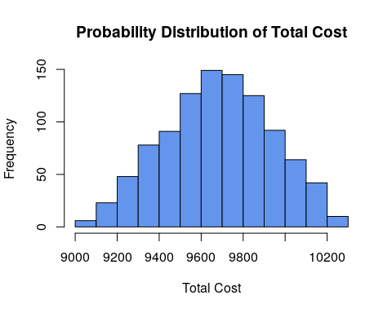

*Figure 2.2 – Probability Distribution for Ordering Quantity Values*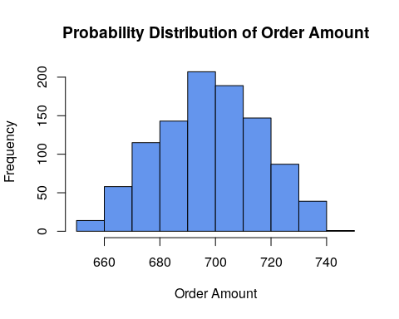

*Figure 2.3 – Probability Distribution for Number of orders*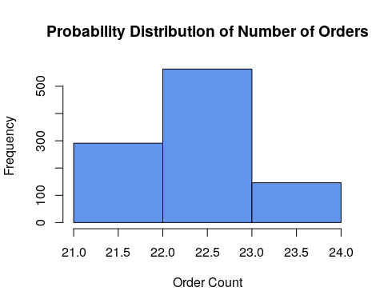

# Conclusion

To conclude, in this analysis, my main aim was to perform what-if scenarios and optimization techniques for an Inventory Management. I was given parameters, data and business scenario and I devised a model for decisions making for optimal inventory management. In the first part, yearly demand for specific product was given as 17700 units, uniformly distributed over the months. I utilized Excel Solver in order devise an optimal model for ordering decision. As a result, I found that in order to minimize to total yearly cost, company should order 24 times a year with 735 units in each order. That will cost them total cost of 10198.1 USD. On the other hand, for the second part I assumed demand to be random number with triangular probability distribution. I utilized simulation analysis with 1000 trials. As a result, I observed Total Cost and Ordering Size to also have triangular probability distributions with peaks at 9700 USD and 690 units respectively. However, number of orders throughout the year has Poisson distribution and 23 is the most likely output for the number of orders.